Interface Model of Soil Freezing and Thawing for Use in Discontinuous Permafrost Hydrological Modelling

É. G. Devoie

University of Waterloo, Waterloo, Ontario, Canada

J. R. Craig, Ph.D.

University of Waterloo, Waterloo, Ontario, Canada

ABSTRACT: A physically-based interface model of active layer evolution and permafrost thaw is presented. This computationally efficient, semi-analytical, non-equilibrium solution to soil the freeze-thaw problem is proposed as a component of hydrological models to describe seasonal ground ice, active layer and permafrost evolution.The model is developed and validated against the Neumann solution and a benchmarked numerical model. Unlike similar semi-analytic models, the interface model does not assume a linear temperature profile. The model is implemented for use in discontinuous permafrost peatlands where soil properties are highly dependent on soil ice content. It is demonstrated that the model is suitable for the representation of active layer and permafrost evolution for one representative year of data. Future applications of the model are proposed such as the simulation of the formation and evolution of taliks (perennially thawed soil in permafrost environments), the stability of permafrost, and many others.

KEY WORDS: Discontinuous permafrost, freeze-thaw, hydrology, permafrost modelling, semi-analytical.

# Introduction

Modelling is a useful tool to test hypotheses about system function and project possible future system states. In the discontinuous permafrost environment, the appropriate representation of permafrost and seasonal ground ice thaw is essential. The presence of frozen soil strongly affects not only the hydrology, but also the thermodynamics, soil chemistry and ecology of regions experiencing freezing soils (Hayashi 2013). Practically, it is essential to accurately model soil freeze-thaw because it controls many important processes including infiltration, the migration of soil moisture to the surface during freezing, winter quiescence of hydrological systems, and the destabilization of soils, especially in the permafrost region (Gray et al. 2001; Harlan 1973; Stähli et al. 1999; Woo 2012; Nelson et al. 2001). To date, the most accurate models representing discontinuous permafrost been local continuum models such as SUTRA-ICE (Mcclymont et al. 2013, McKenzie et al. 2007).

Though these models accurately represent non-equilibrium processes of soil freeze thaw, and have the ability to simulate multiple thawing fronts in complex domains, they are notoriously numerically expensive (Slater et al. 1998). This can make them inappropriate for large-scale modelling, sensitivity analysis, or hypothesis testing, and leads to the desire to use more efficient 1-D vertical freeze-thaw models, such as NEST and many others (Atchley et al. 2015, Goodrich 1978, Yu Zhang et al. 2003). Though these models solve the heat equation only in one spatial dimension, they can be coupled through source/sink terms to approximate important lateral fluxes (Hinzman et al. 1998). A study site can be broken into HRUs representing the thermal properties of the soil allowing for semi-distributed freeze-thaw modelling. However these 1-D models are still computationally demanding (Kurylyk et al. 2014), which can deter multiple simulations.

In an effort to solve the freeze-thaw problem more efficiently, analytical or semi-analytical solutions have been proposed. These solutions make simplifying assumptions so that it is possible to solve the heat equation directly. These simplifications include neglecting sensible heat transfer (Hayashi et al. 2007), assuming an equilibrium temperature profile (M Woo et al. 2004), time-invariant soil properties (Semenova and Lebedeva 2013), tracking only one freeze/thaw interface (Krogh et al. 2017) and simplifying surface boundary conditions (M Woo et al. 2004), among others. A comprehensive review of current thermal models was completed by Kurylyk & Watanabe (2013).

Freeze-thaw models based on analytic or semi-analytic solutions of the Stefan problem (e.g. Hayashi et al. 2007; Hinzman et al. 1998; Krogh et al. 2017; Semenova & Lebedeva 2013; Woo et al. 2004; Zhang et al. 2003) cannot represent the dynamic three-tiered system (permafrost-talik-active layer). These models may be inappropriate for modelling degrading permafrost at the local scale because they assume a single (often linear) temperature profile between the soil surface and the (single) freeze/thaw front. It is thought that the formation of taliks is the first step in permafrost degradation (Connon et al. 2018). Existing continuum models that do not assume a linear temperature profile (e.g. Mckenzie & Mckenzie 2007; Zhang et al. 2008; Frampton et al. 2011; Daanen et al. 2008; Karra et al. 2014; Schaefer et al. 2009) have thus far focused on longer-term lateral permafrost extent, water seepage, or other processes not associated with the formation and expansion of isolated taliks.

The initiation of an isolated talik has been simulated by Frampton et al. 2011; Atchley et al. 2015; Yi et al. 2014; Endrizzi et al. 2014 and Rawlins et al. 2013, where controls on the active layer such as saturation, snow cover, and ponded water were quantified. These studies shed light on processes governing active layer thickness as defined by maximum thaw depth, but talik formation was not their focus.

The aim here is to address the need for a computationally efficient, physically-based semi-analytical model of active layer evolution and permafrost thaw. This semi-analytical, non-equilibrium solution to soil the freeze-thaw problem does not place constraints on temperature boundary conditions, allows multiple and dynamic freeze/thaw fronts to be tracked simultaneously, tracks only a small number of state variables and does not neglect sensible heat. This model is proposed as a component of hydrological models to describe seasonal frost, active layer and permafrost evolution.

# METHODS

The initial proposed interface model represents the ground using one to three (with the potential for more) representative dynamic domain elements, depending on the season and history. This progression is conceptually represented in Figure 1. In order to track the evolution of the system, it is necessary to know the energy stored in each element (in this case the energy is stored as a mean temperature), as well as the temperature gradients at the interface between elements to drive evolution of these interfaces, where the change in interface position is given by:

$Δz= -\frac{1}{ηρL_{f} }\left[λ_{z+}{\left(\frac{∂T}{∂z}\right)}_{z+}-λ_{z-}{\left(\frac{∂T}{∂z}\right)}_{z-}\right]$ [1]

Where $z$ is depth, $η$ is porosity, $ρ$ is density, $L_{f}$ is latent heat of fusion, $λ$ is thermal conductivity and $T$ is temperature.

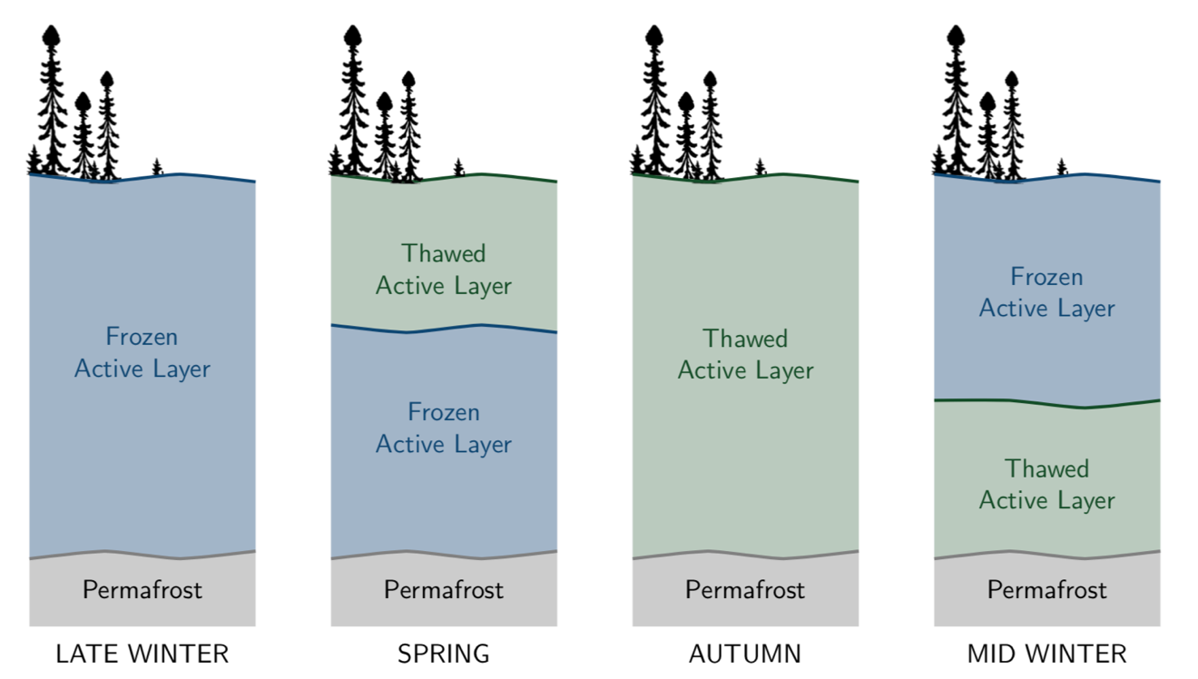

Figure 1: Seasonal transition in soil profile

* 1. Free-boundary problem

The temperature of the surface element, whether thawed or frozen, is governed by the heat equation with an arbitrary, time-dependent boundary condition. The solution to the heat equation in a fixed domain with constant boundary conditions presented by Carslaw & Jaeger 1959 can be extended to solve this problem by applying the principle of superposition. This principle can be repeated for consecutive arbitrary perturbations in surface temperature, allowing the underlaying layer to respond directly to the history of applied surface forcing temperature. Note that this relieves the need to track the entire temperature profile at points in this surface layer, as we need only a representative temperature (energy), and the gradient at the base of the layer to compute the heat flux and consequently the change in thickness and the reduction in mean temperature.

This solution is exact in a domain of fixed length when an infinite number of terms are retained. Given the high thermal conductivity of water and high porosity of peat soils found at the study site, truncating the sum results in little error. In order to account for a change in length, a linear stretching of the profile is assumed, which results in an over-estimate of the energy contained in the profile. Note that this applies both in the frozen and thawed case, where the difference lies only in the values of thermal conductivity and heat capacity.

* 1. Confined layer

A confined layer of thawed (or frozen) soil between the frozen (thawed) surface and the underlaying permafrost (perennially thawed ground) is possible (e.g. SPRING and MID-WINER in Figure 1). In these cases, the heat equation is subject to isothermal boundary conditions at the freezing point, and it is assumed that the initial temperature profile can be approximated by a sinusoidal relationship. A linear correction is applied to this solution to account for changes in length of the profile. A zero or a linear gradient is assumed in the underlying permafrost, with some constant temperature defined at the bottom boundary, and the surface of this layer at the freezing point.

* 1. Mass balance

# Results and discussion

Two benchmarking exercises are presented to validate the model, first the free boundary problem is compared to the Neumann solution (Kurylyk et al. 2014), and secondly the confined layer solution is benchmarked against a continuum finite volume model. The utility of the model is demonstrated by comparing the efficiency of the interface model and the continuum model for the confined case. Finally, a representative one-year simulation of a permafrost is presented as an example application of the model.

* 1. Neumann solution benchmark

The interface model solution is compared to the analytical Neumann solution for thermal properties of pure water with an initial temperature of 0˚C and an imposed surface temperature of 5˚C in Figure 2. The error in thaw depth approximation was approximately 0.5 cm over the course of the 100-day simulation, and over a 1000-day simulation the error grew to approximately 1 cm.



Figure 2: Neumann solution benchmark, interface model subject to constnt temperature boundary conditiom as in Neumann problem.

* 1. Confined layer benchmark

The confined problem can be benchmarked against an analytical energy balance, where the sensible heat contained in an initial temperature profile is used as latent heat to determine the expected thaw. This expected thaw is shown as filled circles in Figure 3, while the modelled temperature profile over the course of a 1000-day simulation is shown as curves which get progressively darker with time. After 1000 days, the modelled solution reproduces 100.23 % of the predicted thaw with an initial length of $L=$ 0.1 m and $T_{0}=1^{∘}$ C.



Figure 3 : Benchmarking confined problem for a 1000 day simulation, temperature profiles are plotted at uneven timesteps and get darker as time progresses. Note that the profiles are calculated for vizualization and are not necessary for tracking the interface.

* 1. Mass balance benchmark
  2. Model comparison

The confined case was further compared to a continuum model solving the same problem with the same initial conditions on the same domain. Over the 1000-day simulation, the continuum model resulted in 79 % of the analytically computed thaw, with temperature profiles nearly identical to Figure 3. This comparison was made using the total loss of ice content as a proxy for change in profile length since partially frozen soil is allowed to exist in the continuum model where a soil freezing curve was defined between -0.05 and 0 ˚C. The equilibrium condition for this simulation would be an isothermal, uniformly partially frozen soil column where the change in total ice content is expected to be slightly less than the predicted sharp-interface problem because of the sensible heat included in the non-isothermal phase change. For this reason, the results are also compared in Figure 4, where the freezing front modelled using the interface model falls beyond the -0.025 ˚C isotherm, where the ice content is 50 %.



Figure 4: Interface location of interface model (solid line) compared with contour plot of temperature generated from continuum model data. Note that the interface is located between 0 and -0.05, the region over which the freezing function is defined.

This simulation had a computational time of 0.681 s using the interface model, while the continuum model ran for 28.1 min s to solve the same problem. This represents a ~ 2500-fold increase in model efficiency, making previously computationally prohibitive tasks such as sensitivity or uncertainty analyses, model calibration, and Monte-Carlo simulations feasible.

* 1. Example application

The interface model was developed for the representation of active layer evolution and changes in permafrost table in hydrological modelling. Figure 5 presents a representative one-year simulation of ground ice conditions, forced with a simple sinusoidal temperature profile. The results of this simulation is consistent with field observations made on peat plateaux at the Scotty Creek Research Station, where high porosity soils are near saturation year-round (Connon et al., 2018).

Note in Figure 5 the break in slope during thaw occurs when the regime shifts from the free boundary problem to the confined solution – further work is needed to smooth the transition. This break in slope coincides with the start of refreeze. The slope of the soil freezing curve is greater than the thawing curve due to the increased thermal conductivity of ice as compared to water.

Though a simple sinusoidal boundary condition is applied in this case, no restrictions are placed on this condition, and arbitrary temperature or flux profiles are sufficient as a surface boundary condition. This tool is not only applicable in permafrost environments, it can be easily extended to represent seasonal ground ice in more temperate regions by changing the boundary and initial conditions as well as soil properties.

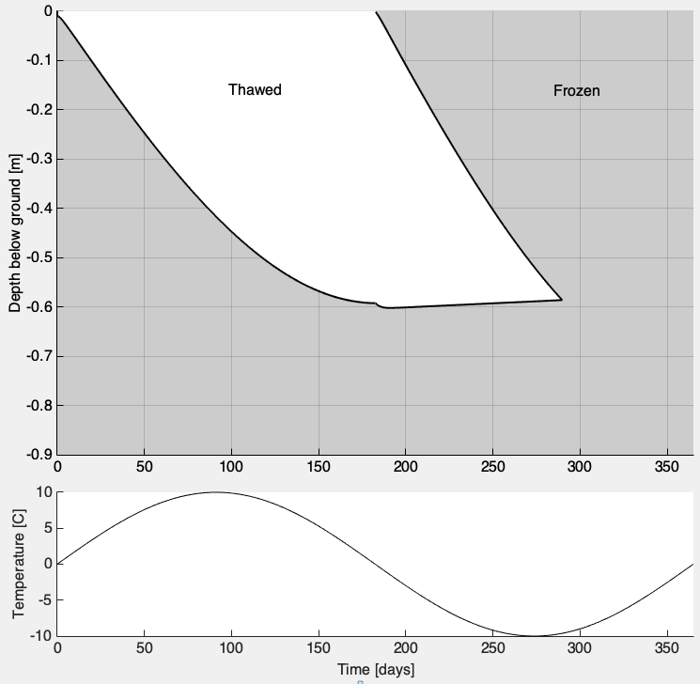

Figure 5: Simulation of hypothetical year of freeze-thaw data, from spring to spring. Top figure denotes surface temperature. Black lines indicate the position of the freezing/thawing front. Note the break in slope coincides with the beginning of winter.

# Conclusion

The proposed interface model is adequate for the simulation of permafrost degradation and annual freeze-thaw, as well as the representation of seasonal ground ice. Results agree well with analytical solutions and a benchmarked continuum model, though the interface model demonstrates an approximate 2500-fold increase in computational speed. This tool can be applied to better understand the condition of permafrost in peatlands in the SCRS, allowing for sensitivity analysis and calibration to be feasible. The model can easily be extended to represent seasonal ground ice and different soil types. Next steps in model development include incorporation time-varying soil moisture conditions, as well as segregated ice development and their impacts on hydraulic conductivity and pore volume.

ACKNOWLEDGEMENTS

The authors would like to acknowledge the travel funding support offered by the CPA.

REFERENCES

Atchley, A. L., Painter, S. L., Harp, D. R., Coon, E. T., Wilson, C. J., Liljedahl, A. K., and Romanovsky, V. E. (2015). *Using field observations to inform thermal hydrology models of permafrost dynamics with ATS ( v0 . 83 )*, (September).

Carslaw, H. S., and Jaeger, J. C. (1959). *Conduction of Heat in Solids*.

Connon, R., Devoie, É., Hayashi, M., Veness, T., and Quinton, W. (2018). *The influence of shallow taliks on permafrost thaw and active layer dynamics in subarctic Canada*. Journal of Geophysical Research: Earth Surface, 1–17.

Daanen, R. P., Misra, D., Epstein, H., Walker, D., and Romanovsky, V. (2008). *Simulating nonsorted circle development in arctic tundra ecosystems*, *113*(July), 1–10.

Endrizzi, S., Gruber, S., Amico, M. D., and Rigon, R. (2014). *GEOtop 2 . 0 : simulating the combined energy and water balance at and below the land surface accounting for soil freezing , snow cover and terrain effects*, 2831–2857.

Frampton, A., Painter, S., Lyon, S. W., and Destouni, G. (2011). *Non-isothermal , three-phase simulations of near-surface flows in a model permafrost system under seasonal variability and climate change*. Journal of Hydrology, *403*, 352–359.

Goodrich, L. E. (1978). *Efficient numerical technique for one-dimensional thermal problems with phase change*. Internatuional Jurnal of Heat and Mass Transfer, *21*, 615–621.

Gray, D. M., Toth, B., Zhao, L., Pomeroy, J. W., and Granger, R. J. (2001). *Estimating areal snowmelt infiltration into frozen soils*. Hydrological Processes, *15*(16), 3095–3111.

Harlan, R. L. (1973). *Analysis of coupled heat and fluid transport in partially frozen soil*. Water Resources Research, *9*(5), 1314–1323.

Hayashi, M. (2013). *The Cold Vadose Zone: Hydrological and Ecological Significance of Frozen-Soil Processes*. Vadose Zone Journal, *12*, 2136.

Hayashi, M., Goeller, N., Quinton, W. L., and Wright, N. (2007). *A simple heat-conduction method for simulating the frost-table depth in hydrological models*. Hydrological Processes, *2622*, 2610–2622.

Hinkel, K. M., Paetzold, F., Nelson, F. E., and Bockheim, J. G. (2001). *Patterns of soil temperature and moisture in the active layer and upper permafrost at Barrow , Alaska : 1993 – 1999*, 1993–1999.

Hinzman, L. D., Goering, D. J., and Kane, D. L. (1998). *A distributed thermal model for calcuatiing soil temperature profiles and depth of thaw in permafrost regions*, *103*(98).

Karra, S., Painter, S. L., and Lichtner, P. C. (2014). *Three-phase numerical model for subsurface hydrology*, 1935–1950.

Krogh, S. A., Pomeroy, J. W., and Marsh, P. (2017). *Diagnosis of the hydrology of a small Arctic basin at the tundra-taiga transition using a physically based hydrological model*. Journal of Hydrology, *550*, 685–703.

Kurylyk, B. L., McKenzie, J. M., MacQuarrie, K. T. B., and Voss, C. I. (2014). *Analytical solutions for benchmarking cold regions subsurface water flow and energy transport models: One-dimensional soil thaw with conduction and advection*. Advances in Water Resources, *70*, 172–184. https://doi.org/10.1016/j.advwatres.2014.05.005

Kurylyk, B. L., and Watanabe, K. (2013). *The mathematical representation of freezing and thawing processes in variably-saturated, non-deformable soils*. Advances in Water Resources, *60*(August), 160–177.

Mcclymont, A. F., Hayashi, M., Bentley, L. R., and Christensen, B. S. (2013). *Geophysical imaging and thermal modeling of subsurface morphology and thaw evolution of discontinuous permafrost*. Journal of Geophysical Research: Earth Surface, *118*, 1826–1837.

McKenzie, J. M., Voss, C. I., and Siegel, D. I. (2007). *Groundwater flow with energy transport and water-ice phase change: Numerical simulations, benchmarks, and application to freezing in peat bogs*. Advances in Water Resources, *30*(4), 966–983.

Mckenzie, J., and Mckenzie, J. M. (2007). *Groundwater Flow with Energy Transport and Water-Ice Phase Change : Numerical Simulations , Benchmarks , and Application to Freezing in Peat Bogs freezing in peat bogs*, (April 2016).

Rawlins, M. A., Nicolsky, D. J., Mcdonald, K. C., and Romanovsky, V. E. (2013). *Simulating soil freeze / thaw dynamics with an improved pan-Arctic water balance model*, *5*(October 2012), 659–675.

Schaefer, K., Zhang, T., Slater, A. G., Lu, L., Etringer, A., and Baker, I. (2009). *Improving simulated soil temperatures and soil freeze / thaw at high-latitude regions in the Simple Biosphere / Carnegie- Ames-Stanford Approach model*, *114*, 1–18.

Semenova, O., and Lebedeva, L. (2013). *Simulation of subsurface heat and water dynamics , and runoff generation in mountainous permafrost conditions , in the Upper Kolyma River basin , Russia*, 107–119.

Slater, A. G., Pitman, A. J., and Desborough, C. E. (1998). *Simulation of freeze-thaw cycles in a general circulation model land surface scheme*. Journal of Geophysical Research, *103*(D10), 11303–11312.

Stahli, M., Jansson, P., and Lundin, L. (1999). *Soil moisture redistribution and infiltration in frozen sandy soils*, *35*(1), 95–103.

Woo, M., Arain, M. A., Mollinga, M., and Yi, S. (2004). *A two-directional freeze and thaw algorithm for hydrologic and land surface modelling*, *31*, 1–4.

Woo, M. K. (2012). *Permafrost hydrology*. *Permafrost Hydrology* (Vol. 9783642234).

Yi, S., Wischnewski, K., Langer, M., Muster, S., and Boike, J. (2014). *Freeze / thaw processes in complex permafrost landscapes of northern Siberia simulated using the TEM ecosystem model : impact of thermokarst ponds and lakes*, 1671–1689.

Zhang, Y., Carey, S. K., and Quinton, W. L. (2008). *Evaluation of the algorithms and parameterizations for ground thawing and freezing simulation in permafrost regions*. Journal of Geophysical Research Atmospheres, *113*(17).

Zhang, Y., Chen, W., and Cihlar, J. (2003). *A process-based model for quantifying the impact of climate change on permafrost thermal regimes*, *108*.